BIBLICAL DOCTRINES

We believe the following to be essential Doctrines of the Christian Faith:
- The Inspiration of the Scriptures
- The Virgin Birth of Jesus Christ
- The Deity of our Lord Jesus Christ
- The Vicarious Death of Jesus Christ
- The Bodily Resurrection of our Lord Jesus Christ
- The Second Coming of our Lord Jesus Christ

Brazilan Consulate for DE, NJ, NY, PA, and Bermuda
- Must appear in person

Brazilian Consulate General in New York
1185 Avenue of the Americas
(6th Avenue), 21st Floor
New York, NY 10036

For More Application or Questions Contact:
FFBC
979 Whig Lane
Monroeville, NJ 08343
Or
Pastor Stephen J. Racite
VP STAMP
845.534.3335
sracite@verizon.net
A Ministry of the Fellowship of Fundamental Bible Churches

Short
Term
Apprentice
Missionary
Program
Rio de Janeiro, Brazil
June 16 - 27, 2014

Purpose
Work with BMM Missionary Brendan Holmquist to assist their fellowship of churches during the 2014 FIFA World Cup of Soccer
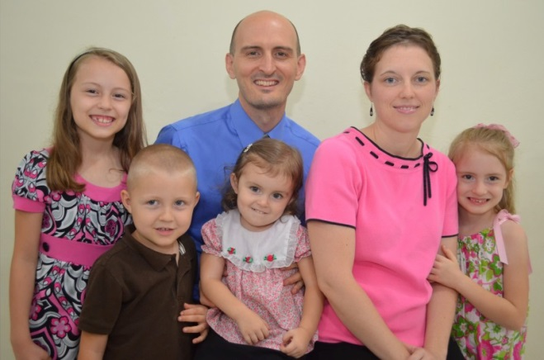
Holmquist Family
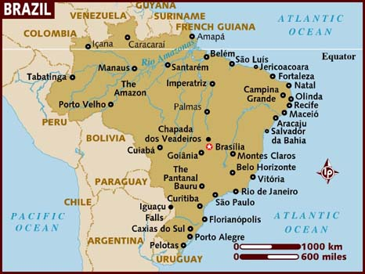
Rio de Janeiro, Brazil
- 2nd largest city in Brazil
- 3rd largest metropolitan area in South America
- 26th largest city in the world
- 6 million people in the city proper
- 12 million people in the greater Rio area
Rio de Janeiro is overwhelmingly Roman Catholic with atheism and spiritism on the rise. Growth has been seen in the Pentecostal churches. Theological knowledge is minimal and religious confusion is rampant. The primary language in Rio de Janeiro is Portuguese.
"Rio de Janeiro is the most visited city in the southern hemisphere and is known for its natural settings, carnival celebrations, samba, Bossa Nova, balneario beaches[10] such as Barra da Tijuca, Copacabana, Ipanema, and Leblon. Some of the most famous landmarks in addition to the beaches include the giant statue of Christ the Redeemer ('Cristo Redentor') atop Corcovado mountain, named one of the New Seven Wonders of the World; Sugarloaf mountain (Pão de Açúcar) with its cable car; the Sambódromo, a permanent grandstand-lined parade avenue which is used during Carnival; and Maracanã Stadium, one of the world's largest football stadiums. The 2016 Summer Olympics will take place in Rio de Janeiro, which will mark the first time a South American city hosts the event. Rio's Maracanã Stadium will also host the final match for 2014 FIFA World Cup." WikiPedia

PLAN
- Outreach at matches
- Personal evangelism
Cost: $3,000
– includes transportation, housing, and meals
Extra Costs (not included):
Visa – required from Brazilian Consulate
Medical Shots – from personal physician
Souvenirs
Must be 18 or Older

